**RESUME**

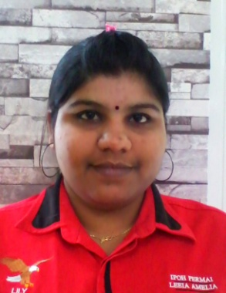

**LILY A/P SUNDARAM**

CAREER OBJECTIVE

To obtain a challenging and responsible position where I can contribute the best of my skills and efforts for the growth.

PERMANENT ADDRESS

No. 11199, TAMAN SENTOSA PERDANA,

PERSIARAN 3, SUNGAI SIPUT (U),

31100, SUNGAI SIPUT

Tel (mobile) : +014 6031915

E-mail : lily121410@live.com

PERSONAL PARTICULAR

Age : 30 years Date of Birth : 14 JUNE 1985

Nationality : Malaysian Gender : Female

Marital Status : Married Identity No. : 850614085274

EDUCATION BACKGROUND

**Further Education**

Level : Executive Diploma In Office Administration

Specialization : HR & Admin (Management) Result : 3.78

Institute : UniversitiTun Abdul Razak Result : 3.48

SKILL

* Proficient in Microsoft Word, Power Point, and Excel.
* Fluent in written Bahasa Malaysia and English and Tamil, speak Malay and understand English order and Tamil.

EXPERIANCE

- 2013 – Present : HR & Account Executive (IPOH PERMAI TRAVEL & TOURS

SDN.BHD.)

* 2012 – 2013 : Clerk under Account department (LEAN KEE CHAN SDN.BHD.)
* 2005-2009 : Staff under Program Management Team (FINISAR (M) SDN.BHD.)
* 2003-2005 : Tutor (OWN TUITION CLASS)

MISCELLANEOUS

Text resume : Personality

* Able to work in team or independently
* Fast and continuous learner
* Organize well and good team player
* Willing to work hard and learn new things
* High sense of responsibility
* Can work under pressure and meet tight deadlines
* Good interpersonal, proactive, self-motivated and communication skills.

OTHER INFORMATION

Enjoy meeting people and very like work with group. Interested in something new and interested in working in data compilation. My other interests are cooking, music, and sport.

REFERENCES

Personal Reference:

Miss Priya.

Colleague

Tel: 05-2882083

H/P: 016 - 5067394

Mr Raj

TI METAL FORGINGS (M) BHD.

Supervisor

010 5639112